https://www.garyjackson.dev/posts/blockchain-development-smart-contract-hello-world/

https://itnext.io/deploying-smart-contracts-to-binance-smart-chain-with-truffle-c57a7d1eb6ed

1. Xử lý khi gặp lỗi

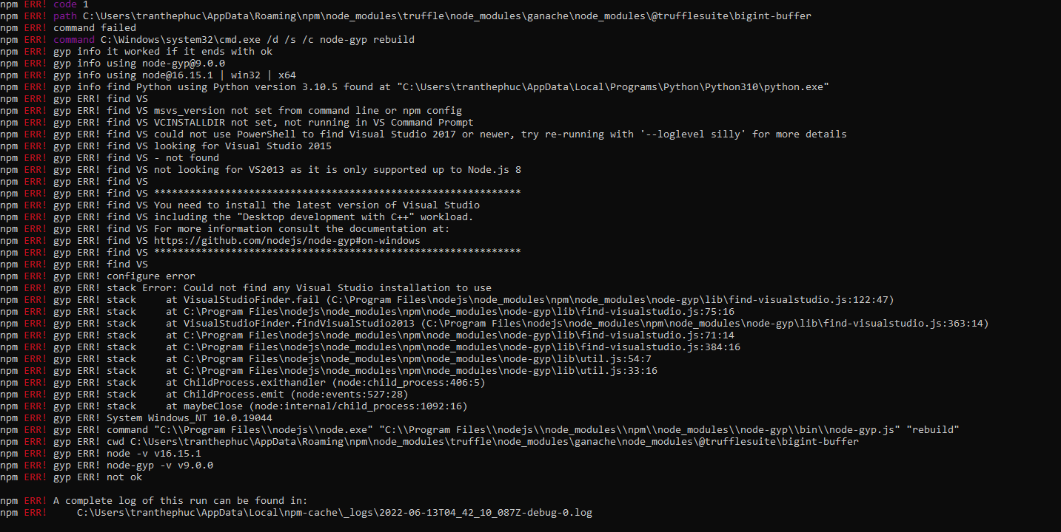

* Thực hiện theo hướng dẫn trong trang web sau: <https://www.mongodb.com/community/forums/t/npm-install-command-failing-with-message-could-not-find-visual-studio/121367>

1. Smart contract tutorial

pragma solidity ^0.4.0; 🡺 It’s use exactly version 0.4.0 of Solidiy

+ Functions: Collection of code

+ States: Data

1. Variable

+ State variable: State variable belongs to smart contract

+ Local variable: It always is stored in a function

+ Global variable: These variable exists in global workspace and provide information about the blockchain and transaction

1. Training References

* Two links as show below is the most popular tutorial for Solidity and Smart Contract

+ Solidity: <https://www.tutorialspoint.com/solidity/index.htm>

+ Smart Contract:

1. FOMO – always ask yourself (Why?)

